**Exercise 1: Create a Stored ProcedureGoal:**

Create a stored procedure to retrieve employee details by department.

Steps:

1. Define the stored procedure with a parameter for DepartmentID.

2. Write the SQL query to select employee details based on the DepartmentID.

3. Create a stored procedure named `sp_InsertEmployee` with the following code:

CREATE PROCEDURE sp_InsertEmployee

@FirstName VARCHAR(50),

@LastName VARCHAR(50),

@DepartmentID INT,

@Salary DECIMAL(10,2),

@JoinDate DATE

AS

BEGIN

INSERT INTO Employees (FirstName, LastName, DepartmentID, Salary, JoinDate)

VALUES (@FirstName, @LastName, @DepartmentID, @Salary, @JoinDate);

END;

**Output:**

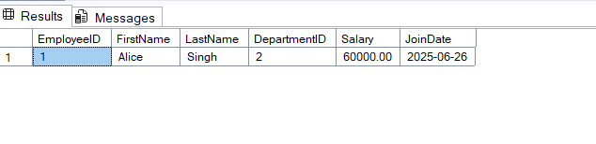

**Code:**

CREATE DATABASE CompanyDB;

GO

USE CompanyDB;

GO

CREATE TABLE Employees (

EmployeeID INT PRIMARY KEY IDENTITY(1,1),

FirstName VARCHAR(50),

LastName VARCHAR(50),

DepartmentID INT,

Salary DECIMAL(10,2),

JoinDate DATE

);

GO

CREATE PROCEDURE sp_InsertEmployee

@FirstName VARCHAR(50),

@LastName VARCHAR(50),

@DepartmentID INT,

@Salary DECIMAL(10,2),

@JoinDate DATE

AS

BEGIN

INSERT INTO Employees (FirstName, LastName, DepartmentID, Salary, JoinDate)

VALUES (@FirstName, @LastName, @DepartmentID, @Salary, @JoinDate);

END;

GO

CREATE PROCEDURE sp_GetEmployeesByDepartment

@DepartmentID INT

AS

BEGIN

SELECT *

FROM Employees

WHERE DepartmentID = @DepartmentID;

END;

GO

EXEC sp_InsertEmployee

@FirstName = 'Alice',

@LastName = 'Singh',

@DepartmentID = 2,

@Salary = 60000,

@JoinDate = '2025-06-26';

GO

EXEC sp_GetEmployeesByDepartment @DepartmentID = 2;